English Policy

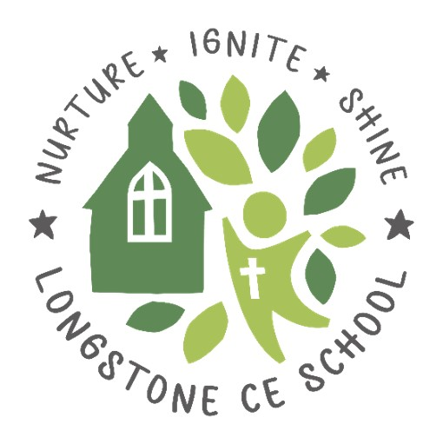

Reviewed/Adopted: May 2024
Next Review Date: May 2025
Reviewed By: Curriculum and Standards

Introduction
This policy outlines our approach to the teaching and learning of English, reflecting the school’s aims and objectives. It sets a framework within which teaching and non- teaching staff can operate. The policy should be read in conjunction with the 2014 National Curriculum. This sets out the rationale for teaching each area of the English Curriculum and specifies the skills that will be developed for the majority of pupils in each year group.

Intent
At Longstone CofE (VA) Primary School, our overall aim is to nurture children’s English skills, so they become proficient readers, writers, spellers and speakers, who can transfer their English skills to other curriculum subjects and who are prepared for the next steps in their education and beyond.
We enable our pupils to shine as members of society by providing them with purposeful opportunities to confidently communicate with others through writing and discussion, as well as encouraging pupils to showcase their individual flair. We aim to ignite our children’s appreciation of our rich and varied literary heritage, as well as grow a lifelong love of reading through developing their fluency and comprehension. Furthermore, we ensure progressive high standards of language and literacy are weaved across the curriculum and strengthened through daily English lessons.

At Longstone Primary School, we aim to encourage all pupils to:
• read easily, fluently and with good understanding
• develop the habit of reading widely and often, for both pleasure and information
• acquire a wide vocabulary, an understanding of grammar and knowledge of linguistic conventions for reading, writing and spoken language
• write clearly, accurately and coherently, adapting their language and style in and for a range of contexts, purposes and audiences
• use discussion in order to learn; they should be able to elaborate and explain clearly their understanding and ideas
• be competent in the arts of speaking and listening, making formal presentations, demonstrating to others and participating in debate.

Statutory Requirements
The National Curriculum (2014) clearly states that teaching the English language is an essential role of a Primary School. The English programme of study is based on four areas; Spoken language, Reading, Writing and Spelling, grammar and punctuation. The National Curriculum is divided into three key stages; Key Stage 1, Lower Key Stage 2 (Years 3 and 4) and Upper Key Stage 2 (Years 5 and 6). By the end of each key stage, pupils are expected to know, apply and understand the matters, skills and processes specified in the relevant programme of study.
The Early Years Foundation Stage Framework (updated 2021) clearly states that communication and language (prime area) underpins all seven areas of learning and therefore, this underpins our approach to English in the Early Years. The framework also details Literacy (specific area) requirements and these two areas of learning are woven through the teaching and learning in the Early Years.

Subject Organisation
English in the Early Years
Developing a love of reading is at the heart of our work within the EYFS. Children enjoy a daily ‘story time’, which is often enhanced with the use of story props and forms the basis of our book talk sessions. Children are encouraged to develop their communication skills through discussion of texts and daily ‘news’ sharing times. Our daily phonics sessions are key to enabling children to quickly develop their skills in blending and segmenting sounds and children have consistent opportunities to practise these skills through engaging opportunities available within both the indoor and outdoor provision. Children have a variety of adult and child-initiated learning opportunities. As well as a Writing Area, which provides children with a range of materials with which to experiment and practice mark making/letter formation (and eventually practice taught skills), other Learning Zones are enhanced to provide children with the opportunity to read and write in a range of contexts. A range of resources in the outdoor area, including a writing shed and mud kitchen provide children with valuable and exciting opportunities to engage children in writing for pleasure. Adult initiated activities in EYFS are linked to stories, poems and nursery rhymes. Children learn that writing can have a range of purposes and they begin to explore the features of different types of writing.

Approaches to Speaking and Listening
The Four Strands of Speaking and Listening: speaking; listening; interactions and drama permeate the whole curriculum. Interactive teaching strategies, such as: role play, conscience alley and hot seating, are used to engage all pupils in order to raise reading and writing standards. Children are encouraged to develop effective communication skills through discrete teaching in class but also through osmosis of observing staff using effective communication skills around school.
Opportunities to develop speaking and listening include: assemblies, talk partners, drama and performances.
We recognise the need for all pupils to speak, read and write Standard English fluently and accurately, while acknowledging that a pupil’s own dialect, or other language is of prime importance. It is our aim to model quality language to the children to encourage Standard English both in speaking and writing.
Approaches to Reading
At Longstone Primary School, Early Reading starts with our Read Write Inc. Phonics programme, which is taught daily to all Reception, Y1 and Y2 pupils. Pupils are streamed into groups based on the current sounds they need to learn using assessments from Phonics Tracker. During the phonic programme, they learn all the phonemes (smallest units of sound i.e. k) and the corresponding graphemes (how those sounds are represented by letters i.e. k, c, qu, ck), so that they can segment and blend words for reading and writing. Each week, children will learn common exception words (red words – see Appendix 1) – these are words which are not decodable using phonic knowledge - as well as a variety of phonetically decodable words incorporating the sound being learnt (green words – see Appendix 2). This learning continues into Key Stage 2, if necessary and it is also supported by interventions for any children not making expected progress. As part of our phonics sessions, once children have learnt Set 1 (single letters), they are exposed to reading short sentences (red ditties) and then phonetically decodable books (Ditty Books). This is so that fluency - pace, expression and accuracy – is explicitly taught and developed. We read the ditty books three times, so that the first read is decoding the words; the second read is improving accuracy and speed and the third read is to improve expression.
A range of reading scheme books are used to support early readers and all these books are matched to the Read Write inc sounds, so that children can practise the sounds they are learning or have learnt whilst reading. Stage books are accessed by children until they are competent, fluent readers, which is usually until Stage 10. Pupils in Reception, Y1 and Y2 are heard read on a 1:1 basis twice a week – this is at least once by the class teacher and then where necessary, once by a teaching assistant.
Once children are competent fluent readers, which is usually when they reach stage 10, they are assessed using Accelerated Reader (AR) and this provides them with a Zone of Proximal Development level linked to colours, which allows them to choose an appropriate chapter book based on their vocabulary and comprehension needs. Pupils in KS2 are heard twice a week, if they access stage books and once every two weeks, if they access AR books. In KS2, if we feel children still need support with their reading fluency, we have a range of high interest books to inspire reluctant or struggling readers. Children in KS2, who need more support with fluency, will access a fluency intervention programme, which will allow children to work with the teacher in small groups following the same guidance as KS1 – the first read is decoding the words; the second read is improving accuracy and speed and the third read is to improve expression. We also have volunteers, who visit the school to provide additional opportunities for children to read.
Pupils should have at least one book, which they read in school and take home. We encourage parents and pupils to record their reading in their school planner, so we can maintain parent-teacher communication but also so we can see the frequency of reading and the type of books children have read. Children are provided with merit stickers for every three times they read.
All classes have daily Whole Class Reading sessions (see Appendix 3), which are based on book talk in EYFS and in KS1 and KS2, this progresses to working on comprehension style questions or diving into and analysing a text, image, video or song. To analyse texts and to support answering comprehension questions, we use ‘Reading Dogs’ (see Appendix 5), which link a character; question stems and strategies to each reading content domain. I.e. Inference Iggy supports our children to learn strategies to answer inference style questions. During Whole Class Reading sessions, the teacher will explore vocabulary and they will also model breakdown strategies (see Appendix 4) to ensure children have the tools to succeed when they come across unfamiliar words.
Furthermore, reading for pleasure and developing a love of reading is important at Longstone School, so all classes have a daily story time, where the teacher reads a high-quality book to the class for enjoyment – these books are organised in our reading spine (Please see Reading Spine Overview). We recognise the value of adults (both in school and at home) reading aloud to children, in order to improve their grasp of story language; enthuse them with a love of books and inspire them as writers. We also hold monthly ‘Read Together’ sessions, where parents can read with their child in school and it provides an opportunity for parents to access the school library. Our mini reading library outside allows books to be shared and borrowed by all at breaktimes and home time. Each class also receives a ‘Mystery Book’ each half term, which only shares the blurb with pupils until the book is unwrapped and read in class. Pupils also have numerous daily opportunities to access books and read independently in class.
Teachers assess reading utilising the Longstone Milestones for Reading (See separate Longstone Milestones) to record progress and assess the gaps in knowledge. Teachers also use 1:1 reading and 1-minute fluency tests to assess fluency; phonics tracker is used to assess phonic knowledge and AR and comprehension tests are used to assess children’s comprehension and reading age.

Approaches to Writing
In our English lessons, we follow a sequence of writing (See Appendix 6), which is: Immerse, Analyse, skills, Plan, Write and Review.
In class, this is an example of how it might look:
- Immerse: introduce an example text, image or object to inspire the writer; introduce the purpose of writing (to entertain/persuade/inform) and use role play or drama to ask questions about the text or act parts of the story out
- Analyse: look at other similar texts and discuss the features of the genre
- Skills: teacher to model the grammar, vocabulary and punctuation needed for the genre and children to practise using the skills needed to be successful
- Plan: talk about ideas for your writing and plan ideas.
- Write: watch the teacher model writing in shared writing sessions; write an independent draft; edit the draft and rewrite your final draft for publishing
- Review: discuss successes and areas for development ready for the next piece of writing
By using this sequence, we aim to develop the children’s ability to produce well-structured, detailed writing in which the meaning is made clear and which engages the interest of the reader. The sequence culminates in every child writing an extended piece of text and this final piece may be as a class, in groups, in pairs or individual depending on the ability and stage of the children. Each half term, we aim for all children to have three final pieces of writing.
The writing sequence allows teachers to model writing strategies and the use of phonics and spelling strategies in shared writing sessions, as well as giving pupils time to explore these strategies for themselves. We always aim to publish the children’s writing in one form or another – either in a class book, on a blog or in a letter.
Furthermore, each half term, each class will cover three types of genre/purpose, usually a fiction (to entertain); a non-fiction (to persuade/to inform) and a poem/rhyme (to entertain or express feelings). As a school, we have organised all the genres of writing into a progression document (see separate Writing Purpose Overview), so the progression of skills and knowledge develop over time.
Pupils are also given the opportunity to allow their creative ideas to flow more freely during ‘Writing for Pleasure’ sessions, which take place every two weeks in KS2 and every half term in KS1. During these sessions, pupils are engaged in writing using an interesting picture or video and they are then given the freedom to write in any style, genre or layout that they choose. As well as this, pupils are also given the opportunity to use technology (laptops and iPads) for their writing.

Approaches to Handwriting
At Longstone Primary, we teach a semi-cursive style of handwriting, which means we teach children to join but we do not teach children to lead into a letter.
In the Early Years, children develop their fine motor and gross motor skills through various activities to ensure their muscles and movements are well-developed in order to start writing. They are then taught the skill of holding a writing tool and they start by making pencil control patterns. During phonic sessions, children are taught to form individual letters, which is further practised in class.
From KS1 upwards, children receive three handwriting sessions a week, which follow a set scheme for practising letter joins. Our handwriting sessions start with a warm up of pencil control activities, then we introduce or recap a letter join and then we introduce three statutory words to practise using our joined handwriting. Sessions may also involve dictation of sentences to practise handwriting in longer pieces and to improve the speed.
Depending on the age, ability and fine motor development of a child, teachers may use specially designed guide lines to support children in forming letters accurately. However, most teachers will teach handwriting using the children’s writing book lines.
(See separate Handwriting Policy)

Approaches to Spelling, Punctuation and Grammar
At Longstone Primary School, teachers are well-equipped to seize the opportunities to enhance pupils’ vocabulary, that arise naturally from their reading and writing. Vital Vocabulary, which as it says is vital for each lesson, is introduced and discussed at the beginning of each lesson. As vocabulary increases, teachers show pupils how to understand the relationship between words. Vital vocabulary also underpins our spelling lessons, so that spellings taught are meaningful and used in a context.
We believe it is important that pupils learn the correct grammatical terms and that these terms are integrated within all teaching. Pupils are discreetly taught spelling and grammatical terms through daily grammar and punctuation sessions, following the Spelling Shed programme of learning. Teachers also take every opportunity to highlight the spelling, grammar or punctuation focus, whether that be during reading sessions or even a different curriculum subject. Teachers assess and plan using the Longstone Milestones, which are statements taken from the National Curriculum to ensure progression across the school. As well as this, pupils are taught to use Standard English and this is modelled throughout the day in all lessons.
Towards the end of Y2 and in KS2, spellings are taught discreetly, daily, using the Spelling Shed Programme of Learning. Children are taught to say the spelling word; to write the spelling word and to understand what the word means. Children also have access to their own Spelling Shed account, which allows them to practise their weekly spellings by playing games and earning points. We encourage children to use this system at home, as well as using it in school. Pupils, who access phonics teaching, also have spellings lists on spelling shed, which focus on the graphemes they have previously learnt.

Assessment
Assessment for learning will take place on a continual basis using techniques such as regular written marking and feedback, teacher observation and on the spot verbal feedback, group discussions, questioning and formative and summative assessments. Marking and feedback will take place in accordance with our ‘Marking and Feedback’ policy. Reading, writing and spelling, punctuation and grammar is assessed using the National Curriculum descriptors (see Longstone Milestones and writing walls) and they are tracked using the EazMag programme. This then shows the gaps and informs teacher’s planning. The subject leader and teachers will work within and across year groups and with other schools to monitor, evaluate and compare assessments.
Phonic knowledge is assessed using Phonic sTracker, which clearly shows the gaps in graphemes. This then informs teacher’s planning and the organisation of phonic groups.

Fluency is assessed using 1:1 reading opportunities and fluency assessments, which are carried out once a term. Reading accuracy and comprehension is assessed using Star Reader tests on Accelerated Reader and this provides all children a reading age, which is used to help teacher’s assess reading. Alongside this, each class teacher will ask children to complete a written comprehension during each half term, which will also aid teacher’s reading assessment.

Writing is assessed against the Longstone writing walls, which have been taken from the National Curriculum and a best fit judgement is made. Cross curricular writing will also be used to inform assessment. Writing assessment is validated using moderation resources and meetings.

Children's progress in English is also assessed using nationally prescribed tests with the Phonics Screening test taking place at the end of Year 1 and children in Year 2 and Year 6 undertaking SATs tests in reading, spelling, punctuation and grammar and teacher assessment in writing. End of Key Stage Assessments are analysed by the Subject Lead and Head teacher and fed into the School Improvement Plan and performance management where appropriate.

Reporting to parents will occur annually in the form of a written report at the end of the year, and through termly Parent Consultation Meetings.

Entitlement and Provision
All children are entitled to an English curriculum that meets their needs. The following is done to try to ensure this happens:
- Our curriculum is inclusive of all children
- Our lessons are designed to help all children make progress
- Parents will be kept informed and encouraged to assist in helping their children.
- Teaching assistants are used to support groups, individual children and/or carry out catch up interventions. This includes additional support outside of the daily English lesson.
- Our curriculum includes a wide range of texts and other resources which represent the diversity and backgrounds.

Resources
We have a range of resources at hand:
- Dictionaries and thesaurus in classrooms and the school library
- Reading books in all classes and the school library
  - Stage books – linked to phonic graphemes
  - Accelerated Reader books – linked to reading age
  - A wealth of different books in the library
- Laptops and iPads
- A reading spine with chosen half termly/termly book boxes for each class
- Pencils, pens and purple polishers for writing tools
- RWI resources for phonic teaching
- Spelling Shed membership
- Accelerated Reader membership
- Classroom Secrets membership
- Phonic Tracker membership
- Twinkl Reading Dogs to teach reading domains
Roles and Responsibilities

It is expected that the English Lead will fulfil the following role:
- To ensure coverage, continuity and progression in planning
- Support colleagues in planning, teaching and assessing English
- Undertake any training, courses, etc. to keep teaching practice and knowledge of new initiatives up-to-date
- Keep colleagues informed of any changes in practice, providing training and/or information when appropriate
- Monitor the planning and teaching of English throughout the school
- Ensure that resources are appropriate, available and of good quality
- Liaise with the head teacher, governors (Curriculum link governor – Mrs L Samson) SENCO and senor leadership team, when necessary
- To monitor and evaluate the effectiveness of English teaching and learning
- To update documentation where necessary
- To provide parents with information about English teaching and learning
- To review regularly the contribution made by English to a meaningful curriculum

English and SMSC (Spiritual, Moral, Social and Cultural)

At Longstone, we promote pupils’ SMSC development through English in the following ways:
- Text choice – we choose texts that represent a range of cultures and situations that will broaden the children’s knowledge of, and respect for different people’s faiths, feelings and values.
- We use debate and discussion of a range of fictional, current or historical situations to develop children’s ability to recognise the difference between right and wrong and explore the consequences of protagonist’s behaviours and actions and make connections with their own lives.
- We teach children to write, to argue, to inform, to persuade and to explain competently, equipping them with the skills to work and socialise successfully with others.
- We study books that cover a range of concepts, themes and situations, including classic texts, develop children’s ability to recognise, and value, the things we share in common across cultural, religious, ethnic and socio-economic communities.

Impact
Children leave Longstone CofE Primary School as happy, confident learners who have developed a love of reading and writing with the key skills and knowledge necessary for the next stage of their learning. They have high aspirations and are confident in the art of speaking and listening, able to successfully use discussion to communicate and further their learning.
- Pupils enjoy reading and writing across a range of genres and for a range of purposes.
- Pupils enjoy reading regularly, for information and for enjoyment.
- Pupils discuss books with excitement and interest.
- Pupils enjoy writing and use the features of different genres and styles.
- Pupils can confidently write for different purposes and audiences.
- Pupils have a wide vocabulary that they use within their writing.
- Pupils have a good knowledge of how to adapt their writing based on the context and audience.
- Pupils leave primary school being able to effectively apply spelling rules and patterns they have been taught.
- Parents and carers will have a good understanding of how they can support pupils’ English development at home.
- The % of pupils working at ARE within each year group will be at least in line with national averages.
- The % of pupils working at Greater Depth within each year group will be at least in line with national averages.
- There will be no significant gaps in the progress of different groups of pupils (e.g. disadvantaged vs non-disadvantaged).

Appendix 1- Read Write inc. Red Words

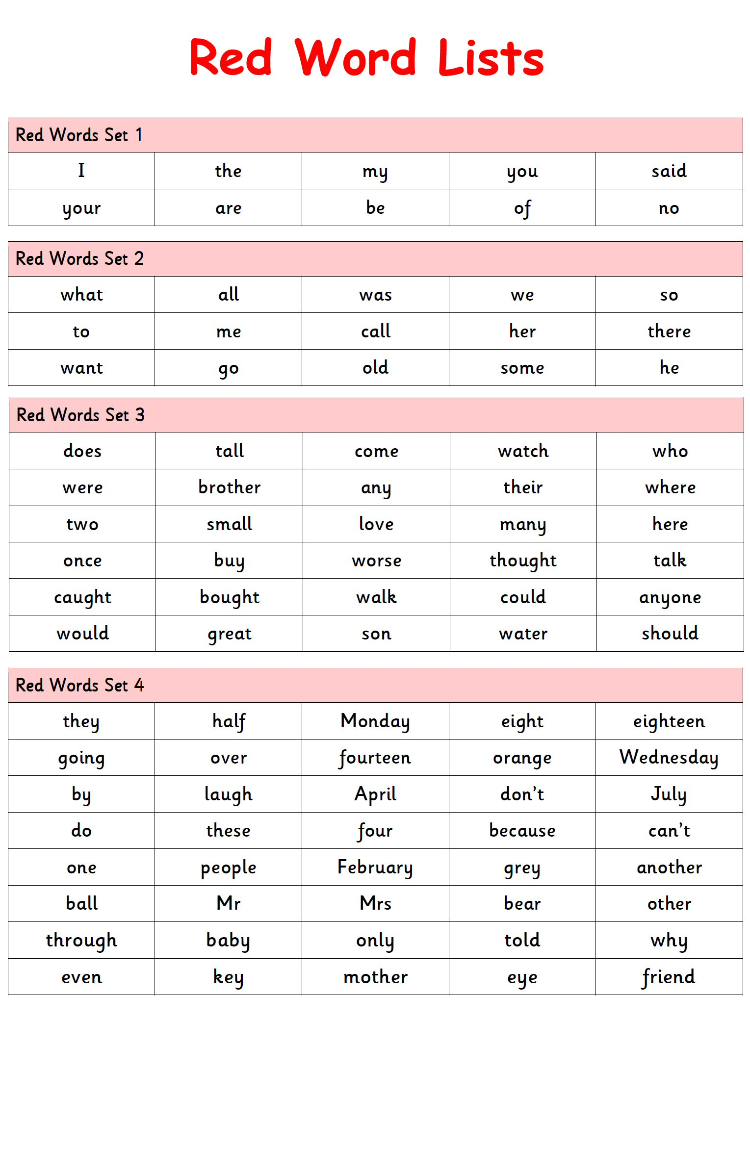

Appendix 2 – Read Write inc. Green Words Example

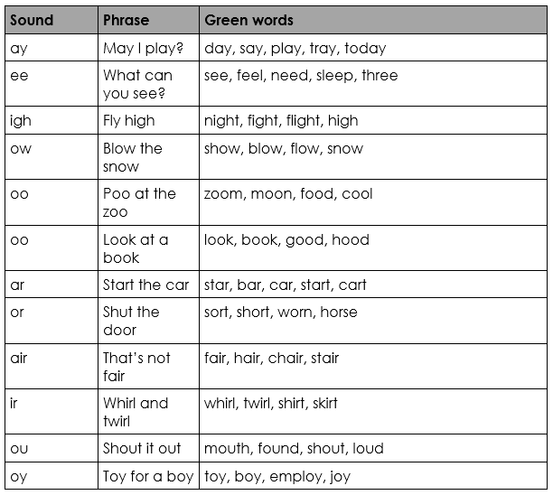

Appendix 3 – Whole Class Reading Sequence
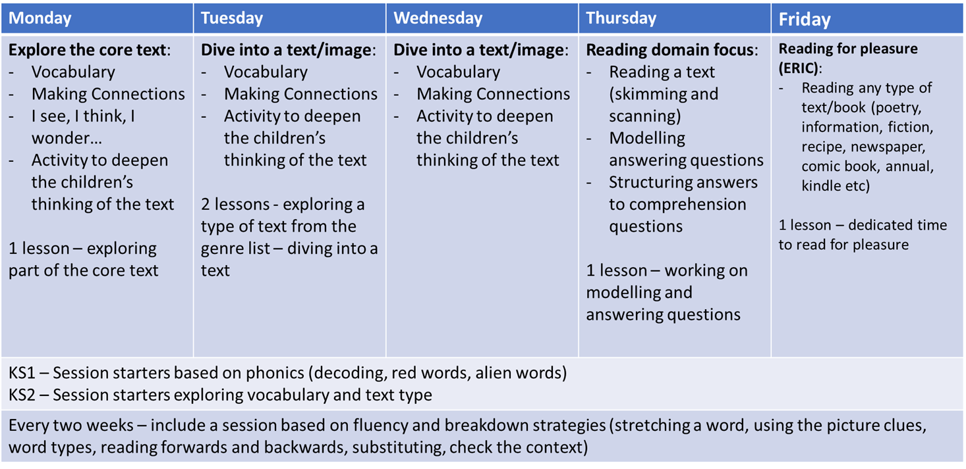

Appendix 4 – VIPERS

KS1

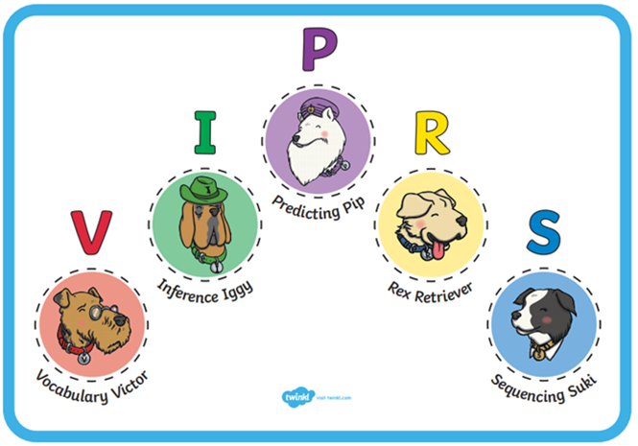
KS2

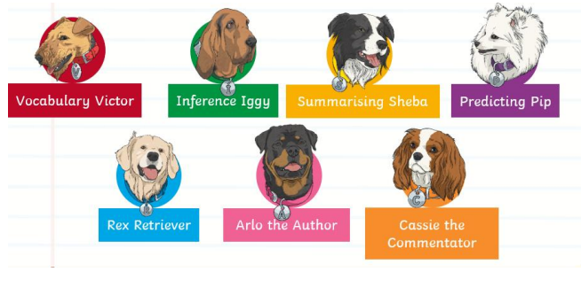

Appendix 5 – Writing Sequence

Teaching sequence |  | Teachers: | Pupils: | Assessment for Learning | Dynamic and supportive writing environment | Talk | Empowering children to become successful writers
Immerse | - Real audience and purpose with a clear outcome.  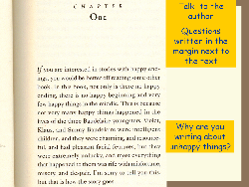  - Broad, rich and engaging reading curriculum.  - Planned drama, speaking and listening opportunities. | Establish clear purpose and audience.  Explain the ‘Big Picture’.  Choose quality challenging texts.  Model reading strategies, i.e. searchlights, inference and deduction, writer’s use of language. (Assessment focuses).  Make links between shared, guided (book study) and independent work.  Start to unpick the writer’s craft.  Begin to gather ideas for writing | Enjoy reading a range of quality texts.  Ask questions.  Link to own experience.  Visualise.  Evaluate.  Identify audience and purpose.  Talk about how they are thinking and learning.  Role play, improvise.
Analyse | - Define features and characteristics of text/genre.  - Agree and understand the success criteria. | 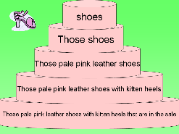  Are secure in knowledge and understanding of structure and language features of text type.  Prioritise which features of text children need to learn – sentence, text, word.  Provide interactive, investigate activities to  meet learning intentions e.g. construct, classify | Identify key features of text type/genre and agree success criteria.  Practise using different features e.g. paired work constructing and varying sentences through speaking and listening activities.
Skills | - Teach the aspects of the success criteria that the pupils have not met or find challenging.  - Focus on grammar / punctuation / vocabulary. | Are secure in the subject knowledge in order to deliver quality first teaching.  Prioritise which features need to be specifically taught – differentiating where necessary e.g. past tense verbs / specific vocabulary | Investigate the skill needed for the specific text type.  Practise writing / using the skill taught in order to be able to apply this in their main writing.
Plan | - Use the success criteria.  - Planned drama, speaking and  listening opportunities. | Provide stimulus and structure for gathering ideas e.g. visual literacy, integrated technologies, drama activities. | Talk about ideas and begin to map them out on a plan e.g. writing skeleton (Sue Palmer) or story map.  Refer to checklist of success criteria – ensure pupils include taught grammar, punctuation and vocabulary skills.
Write | - Demonstration, teacher scribing and supported composition.  - Self and peer assessment.  - Use knowledge of reading to help compose and make informed choices in writing.  - Structured, visual and dynamic Literacy environment. | Are secure in understanding and use of three shared writing techniques.  Model the use of success criteria developed from analysis to inform and evaluate writing.  Integrate word/sentence level with text level to exemplify their application.  Provide stimuli and resources to support and enhance the writing process.  Provide an element of choice. | Are fully aware of the purpose and audience and write accordingly.  Develop a piece of writing over a number of sessions.  Refer to success criteria,  review their writing and  edit in response.  Respond to purposeful  feedback.
Review | - Clear feedback linked to success criteria.  - Understand next steps in developing writing.  - Reflect on outcome against audience and purpose. | Are effective in linking feedback to the success criteria.  Provide planned opportunities for self and peer assessment.  Are confident in identifying areas of success and those for development that will impact on raising the standard of writing, they can explain and set clear ‘next steps’.  Provide further opportunities to write in that particular genre setting up the audience and purpose. | Can reflect on their successes and areas for development. Can identify factors contributing to success and those causing barriers in their work. Are clear in their next steps in learning and engaged in addressing them.  Are enthused by the challenge of using their knowledge to produce written work for a particular audience and purpose.
PRESENT

