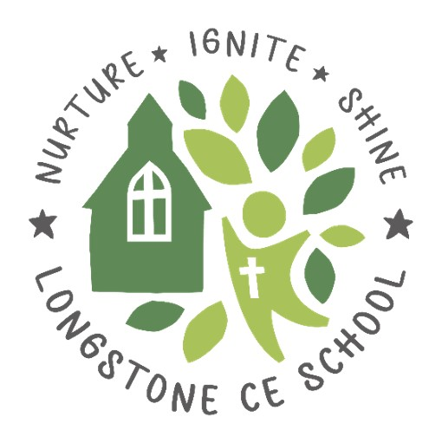
Relationships, Sex and Health Education (RSHE) Policy

Reviewed/Adopted: Jan 2025
Next Review Date: Jan 2026
Reviewed By: Curriculum and Standards

Introductory Statement

Relationship, Sex and Health Education (formerly known as RSHE) is compulsory. As a school we have developed our approaches to meet statutory requirements and teaching. This will include equality, diversity, and difference.

We follow Derbyshire’s PSHE Matters scheme of learning that incorporates RSHE in a progressive manner. This is supplemented by a wide variety of other resources as advocated by PSHE Matters itself.

We acknowledge that there may be times during the teaching of RSHE, that children may need an opportunity to talk to a trusted adult in the school. We will aim to provide that opportunity along with the availability for children to access national organisations and resources that may help with teaching RSHE in our school/setting.

In conjunction with PHSE, RSHE is focussed on giving children the knowledge and skills to be able to know where to find appropriate help and support, both inside the school, school community, and in wider national organizations, for example, Childline.

Our RSHE Curriculum Intent

At Longstone C of E Primary School, we want the teaching of safeguarding to play an integral part in our children’s learning and life. We believe a safeguarding curriculum is essential to enable them to navigate their way through the modern world and be successful, valuable and socially responsible citizens who know how to keep themselves safe and well. Safeguarding children is at the core of our curriculum. By teaching through the Derbyshire PSHE Matters curriculum we ensure that RSHE expectations are met. Through this provision, we nurture our children so that they will be well equipped, with the belief in themselves, to make informed decisions about their life choices and how they impact on their own and others’ lives. In addition to this we prepare them for success and to shine in their education, career and for life in modern Britain both now and in their future. By igniting a curiosity in the aspects surrounding RSHE, we enable our children to develop their own skills, knowledge and understanding of how to be who they are, understand the world they are growing up in and how to keep themselves safe in all areas of their world.

Summary of Parent Consultation

A parent consultation will take place to address:

- For the Parent RSHE Survey to give parents the opportunity to comment on the appropriateness of the materials covered in RSHE in more detail, not just consenting to its teaching in principle.

- Clarify the link between the teaching of RSHE and Safeguarding.

- To be mindful of the appropriateness of ‘the detail/ breadth of info/ agenda being taught’ pertaining issues which have become politicized within the adult world.

- At Primary school level to be very mindful of protecting the innocence of the children where possible.

- If children have questions on more adult themes they can just ask their parents.

- Schools can’t be held responsible for a child’s entire education on this topic, it’s for parents to equip and prepare their children for adult life in an appropriate and timely manner dependent on the needs of their own children.

- That our local area lacks diversity therefore we will strive to help our children to understand other cultures.

RSHE Statement of Intent
It is our vision that RSHE, as an embedded component of the PHSE curriculum, gives pupils the knowledge, skills and understanding they need to lead confident, healthy, independent lives and to become informed, active and responsible citizens.
It is our vision that RSHE enhances our children’s ability to understand themselves within the context of the local and wider world in the areas of relationships and sex education: including in the arenas of anti-bullying; keeping safe on and off line; keeping physically and mentally healthy, learning about drugs, alcohol and tobacco; and the development of skills and attributes such as
communication skills, managing peer pressure, risk management, resilience and decision making.
It is important that RSHE is delivered within a safe, secure and supportive learning environment where children’s genuine questions and concerns can be sensitively addressed. (PSHE Matters: A PSHE Curriculum for Primary Schools V2 2021)

Aims
Through RSHE, we aim for our pupils to develop the skills and knowledge to make informed and empowered decisions. By teaching RSHE within the context of PHSE, we aim to keep the children safe by providing opportunities to gain a knowledge and understanding of their own physical and emotional development. We will provide forums to work with parents/carers to ensure that the teaching of Sex and Relationships Education is a product of consultation with both them, the pupils and external advisory groups such as Public Health England and Derbyshire’s Joint Strategic Needs Assessment.

The Social Context of Longstone CE Primary School
Our RSHE teaching and learning is informed by the context of our immediate local community and is created in joint collaboration and consultation with parents of our children.

The broader social context in which our school exists is one in which there is a need to focus on the issues around:

- Obesity in primary school-aged children
- The impact of free school meals (a proxy indicator of children being from a poorer background) upon learning outcomes and its exponential nature. *²

Teaching and Learning
RSHE is embedded within PHSE, we are committed to creating consistent learning environments by implementing and developing the Ten Principles of Effective pedagogy as outlined in Derbyshire PSHE Matters framework. These principles, are:

- Start where children and young people are: find out what they already know, understand, are able to do and are able to say. For maximum impact involve them in the planning of your RSHE programme.
- Plan a ‘spiral programme’ which introduces new and more challenging learning, while building on what has gone before.
- Take a positive approach which does not attempt to induce shock or guilt but focuses on what children and young people can do to keep themselves and others healthy and safe and to lead happy and fulfilling lives.
- Offer a wide variety of teaching and learning styles within RSHE with an emphasis on interactive learning and the teacher as facilitator.
- Provide information which is realistic and relevant and which reinforces positive social norms.
- Encourage young people to reflect on their learning and the progress they have made, and to transfer what they have learned to say and to do from one school subject to another, and from school to their lives in the wider community.
- Recognise that the RSHE programme is just one part of what a school can do to help a child to develop the knowledge, skills, attitudes and understanding they need to fulfil their potential. Link the RSHE programme to other whole school approaches, to pastoral support, and provide a setting where the responsible choice becomes the easy choice. Encourage staff, families and the wider community to get involved.
- Embed RSHE within other school elements to ensure children and young people have positive relationships with adults, feel valued and where those who are most vulnerable are identified and supported.
- Provide opportunities for children and young people to make real decisions about their lives, to take part in activities which simulate adult choices and where they can demonstrate their ability to take responsibility for their decisions.
- Provide a safe and supportive learning environment where children and young people can develop the confidence to ask questions, challenge the information they are offered, draw on their own experience, express their views and opinions and put what they have learned into practice in their own lives.

Parents’ right to withdraw
- Parents do not have the right to withdraw their children from statutory relationships education.
- Parents only have the right to withdraw their children from the non-statutory components of sex education within RSHE.
- Any concerns will be listened to, and parents are consulted with prior to RSHE teaching.

Roles and Responsibilities
Role of the Headteacher and Senior Leadership Team
- ensure all school personnel are aware of and comply with this policy;
- work closely with the subject leader and school governors.
- ensure compliance with the statuary requirements of RSHE being taught in primary schools by from September 2020.
- Ensure parents/carers are aware that they have a legal right to withdraw their children from dedicated sex education lessons delivered outside the Science Curriculum.
- encourage parents to take an active role in curriculum development;
- provide leadership and vision in respect of equality;
- provide guidance, support and training to all staff;
- monitor the effectiveness of this policy by; observing teaching and learning, planning scrutinies and learning walks, discussions with pupils and members of the school council
- annually report to the Governing Body on the success and development of this policy

Role of the Subject Leader

- lead the development of this policy throughout the school;
- be accountable for standards in this subject area;
- monitor standards by; auditing the subject area, reviewing of the scheme of work, monitoring teachers planning, lesson observations, scrutinising children's work and discussions with pupils
- ensure continuity and progression throughout the school;
- devise a subject improvement plan;
- provide guidance and support to all staff;
- provide training for all staff on induction and when the need arises regarding;
- attend appropriate and relevant INSET;
- keep up to date with new developments;
- undertake an annual audit and stock take of resources.
- purchase new resources when required and in preparation for the new academic year;
- undertake risk assessments when required;
- review and monitor;
- annually report to the Governing Body on the success and development of this policy

Role of Teachers

- comply with all aspects of this policy;
- work closely with the subject leader to develop this policy;
- devise medium and short term planning;
- develop pupils' spoken language, reading, writing and vocabulary in relation to RSHE
- plan and deliver good to outstanding lessons;
- plan differentiated lessons which are interactive, engaging, of a good pace and have a three part structure;
- have high expectations for all children and will provide work that will extend them;
- assess, record and report on the development, progress and attainment of pupils;
- achieve high standards;
- celebrate the success of pupils in lessons;

Entitlement, Timetabling and Progression
We recognise that it is a statutory responsibility to deliver RSHE and the tremendous benefits it can bring to the life of a school, its pupils and community.

Timetabled PHSE takes place for a minimum of 1 hour a week. It is up to the teacher to decide what is covered.’ Within this context, all the curricular objectives of RSHE will be addressed.

Our school has adopted the non-prescriptive approach for RSHE as advocated by PSHE Matters as a means of developing a bespoke and relevant curriculum based on pupils' and community needs.

Lessons will be taught as a complete key stage and use the following timetable as a guide to the order of coverage:

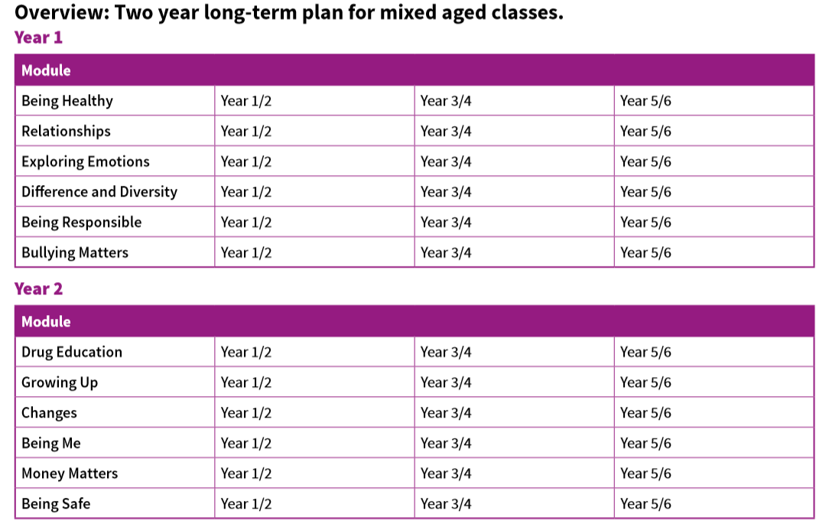

Distinct RSHE Objectives within PHSE
The DfE recognises 5 elements to Relationships Education. These are:

- Families and people who care for me
- Caring friendships
- Respectful relationships
- Online relationships
- Being safe

In Key Stage 1 (age 5-7) children will learn about recognising naming and managing their emotions; what makes them special; what makes a good friend; how to be kind to others; what’s special about them and their families; how families are different; life cycles; about changes and how they have changed since babyhood.

In Lower Key Stage 2 (age 7-9) pupils learn about change in friendships, relationships and families; how to be a good friend online and offline; managing conflict in friendships; staying safe online; about feelings and how to cope with them; about privacy, boundaries and secrets and who to talk to if they feel anxious or unhappy.

In Upper Key Stage 2 ( age 9-11) pupils learn about the important relationships in their life; about how to show love to others; the different kinds of families and partnerships ; about marriage and stable loving relationships and their importance for having babies and bringing up children; how to recognise healthy and unhealthy relationships; the different types of bullying, why they are unacceptable and how to respond; the physical and emotional changes in puberty, including menstruation, and how to cope with them; how babies are conceived, how they develop and are born; the impact of social media on self-esteem, body image, health and safety and ways to manage this.
At the end of their time at Longstone School, pupils will know:

Families and people who care for me
Pupils should know:
- that families are important for children growing up because they can give love, security and stability
- the characteristics of healthy family life, commitment to each other, including in times of difficulty, protection and care for children and other family members, the importance of spending time together and sharing each other’s lives
- that others’ families, either in school or in the wider world, sometimes look different from their family, but that they should respect those differences and know that other children’s families are also characterised by love and care
- that stable, caring relationships, which may be of different types, are at the heart of happy families, and are important for children’s security as they grow up
- that marriage represents a formal and legally recognised commitment of two people to each other which is intended to be lifelong
- how to recognise if family relationships are making them feel unhappy or unsafe, and how to seek help or advice from others if needed

Caring friendships
Pupils should know:
- how important friendships are in making us feel happy and secure, and how people choose and make friends
- the characteristics of friendships, including mutual respect, truthfulness, trustworthiness, loyalty, kindness, generosity, trust, sharing interests and experiences and support with problems and difficulties
- that healthy friendships are positive and welcoming towards others, and do not make others feel lonely or excluded
- that most friendships have ups and downs, and that these can often be worked through so that the friendship is repaired or even strengthened, and that resorting to violence is never right
- how to recognise who to trust and who not to trust, how to judge when a friendship is making them feel unhappy or uncomfortable, managing conflict, how to manage these situations and how to seek help or advice from others, if needed

Respectful relationships
Pupils should know:
- the importance of respecting others, even when they are very different from them (for example, physically, in character, personality or backgrounds), or make different choices or have different preferences or beliefs
- practical steps they can take in a range of different contexts to improve or support respectful relationships
- the conventions of courtesy and manners
- the importance of self-respect and how this links to their own happiness
- that in school and in wider society they can expect to be treated with respect by others, and that in turn they should show due respect to others, including those in positions of authority
- about different types of bullying (including cyberbullying), the impact of bullying, responsibilities of bystanders (primarily reporting bullying to an adult) and how to get help
- what a stereotype is, and how stereotypes can be unfair, negative or destructive
- the importance of permission-seeking and giving in relationships with friends, peers and adults

Online relationships
Pupils should know:
- that people sometimes behave differently online, including by pretending to be someone they are not
- that the same principles apply to online relationships as to face-to-face relationships, including the importance of respect for others online including when we are anonymous
- the rules and principles for keeping safe online, how to recognise risks, harmful content and contact, and how to report them
- how to critically consider their online friendships and sources of information including awareness of the risks associated with people they have never met
- how information and data is shared and used online

Being Safe
Pupils should know:
- what sorts of boundaries are appropriate in friendships with peers and others (including in a digital context)
- about the concept of privacy and the implications of it for both children and adults; including that it is not always right to keep secrets if they relate to being safe
- that each person’s body belongs to them, and the differences between appropriate and inappropriate or unsafe physical, and other, contact
- how to respond safely and appropriately to adults they may encounter (in all contexts, including online) whom they do not know
- how to recognise and report feelings of being unsafe or feeling bad about any adult
- how to ask for advice or help for themselves or others, and to keep trying until they are heard,
- how to report concerns or abuse, and the vocabulary and confidence needed to do so
- where to get advice, for example family, school or other sources
Assessment
Assessment is central to effective, quality teaching and learning in RSHE. The teaching, learning and assessing of RSHE recognises the following principles:
- To be successful independent learners, children and young people need regular opportunities to reflect on and identify what they have learnt, what needs to be learnt next and what they need to do to continue their learning.
- To enable this to happen, assessment has to be an integral part of the teaching and learning process and needs to focus on clear learning outcomes related to the curriculum and not on behavioural outcomes only. This is important as we are assessing skills, attitudes, knowledge and understanding not behaviour.
- Effective assessment in RSHE requires that the teacher
- find out what pupils already know and understand before embarking on a theme.
- Share learning objectives and outcomes with pupils which will help them to understand the standard of knowledge and skills to aim for or achieve
- Provide formative feedback that helps pupils to identify how to improve
- Teach pupils self-assessment techniques and strategies so that they are able to assess their developing knowledge, understanding, attitudes and skills.
- Differentiate activities
- Include time for reflection and action within the session
- If pupils aren't achieving, consider which different strategies we can put in place to support them more effectively.

Resources
The school has access to a wide range of resources to support the teaching of this subject however, the principle vehicle is the PSHE Matters scheme of work and its associated teaching and assessment resources.

CPD training, guidance documents and online resources are offered by the PSHE Association is offered via their website, including:

• Frequently asked questions about pornography and sharing of sexual images in PSHE education
• Handling complex issues safely in the PSHE education classroom
• Briefing on teaching about puberty
• Summary of the law on consent
• Sex and Relationships Education (RSHE) for the 21st Century

Other resources include:
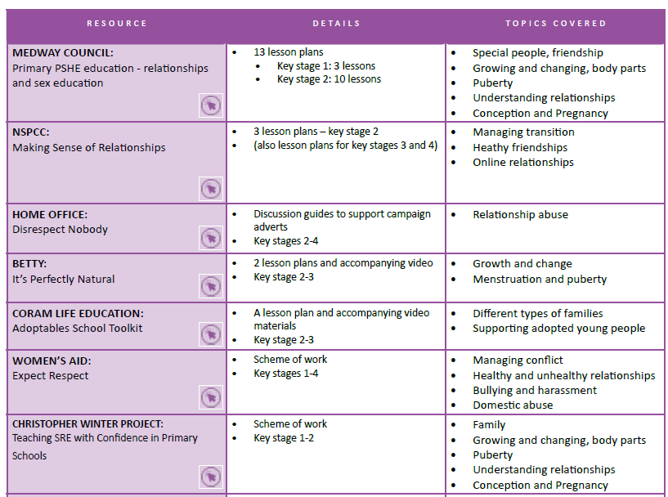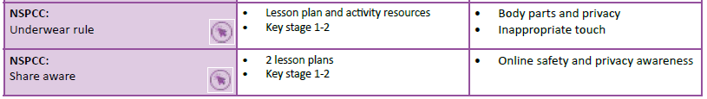

Staffing / Staff Development
- All staff take part in professional development to ensure secure subject knowledge, awareness of health and safety procedures and up to date knowledge. Staff should be comfortable and competent in the area of activity being taught. Staff should indicate where they feel they need support so that appropriate support can be given either by the subject leader or through INSET. Any staff who attend a CPD course provide feedback/ disseminate the information across the school team.
- Longstone staff are familiar with and will teach RSHE in accordance with the Sex Education Forum’s 12 point guide to the Principles of Good RSHE . *⁴ being:
- Is an identifiable part of our personal, social, health and economic (PSHE) education curriculum, which has planned, timetabled lessons across all the Key Stages
- Is taught by staff regularly trained in RSHE and PSHE (with expert visitors invited in to enhance and supplement the programme where appropriate)
- Works in partnership with parents and carers, informing them about what their children will be learning and about how they can contribute at home
- Delivers lessons where pupils feel safe and encourages participation by using a variety of teaching approaches with opportunities to develop critical thinking and relationship skills
- Is based on reliable sources of information, including about the law and legal rights, and distinguishes between fact and opinion
- Promotes safe, equal, caring and enjoyable relationships and discusses real-life issues appropriate to the age and stage of pupils, including friendships, families, consent, relationship abuse, sexual exploitation and safe relationships online
- Gives a positive view of human sexuality, with honest and medically accurate information, so that pupils can learn about their bodies and sexual and reproductive health in ways that are appropriate to their age and maturity
- Gives pupils opportunities to reflect on values and influences (such as from peers, media, faith and culture) that may shape their attitudes to relationships and sex, and nurtures respect for different views
- Includes learning about how to get help and treatment from sources such as the school nurse and other health and advice services, including reliable information online
- Fosters gender equality and LGBT+ (lesbian, gay, bisexual, trans) equality and challenges all forms of discrimination in RSHE lessons and in every-day school life
- Meets the needs of all pupils with their divee experiences including those with special educational needs and disabilities
- Seeks pupils’ views about RSHE so that teaching can be made relevant to their real lives and assessed and adapted as their needs change

Cross Curricular Links
RSHE contributes to many subjects within the primary curriculum particularly statutory science:

KS1
- Identify name draw and label the basic parts of the body and say which sense the part of the body is associated with each sense
- That animals, including humans, have offspring that grow into adults

KS2
- Describe the differences in the life cycle of a mammal, an amphibian and insect and a bird
- Describe the life process of reproduction in some plants and animals
- Describe the changes as humans develop to old age
- Recognise the impact of diet exercise drugs and lifestyle on the way their bodies function
Monitoring and Evaluation of the Subject

Monitoring of standards of children's work and the quality of teaching is the responsibility of the subject coordinator supported by the Headteacher.
Standards will be monitored by: lesson drop ins, observations, pupil voice, audits of work.

Assessment and Recording
Due to the sensitive nature of the subject, assessment will take place through:
- parent consultations
- lesson drop ins
- observations
- pupil voice
- audit of subjects
- general curriculum discussions

These assessments will be used to inform teaching in a continuous cycle of planning, teaching and assessment.

Short-term assessment will be an informal part of every lesson. The teacher will share the objectives for the lesson with the children and make sure they are clear what is being expected of them to successfully achieve the objective. This is a necessary part of AFL and will involve the teacher checking the children’s understanding at the end of the session to inform future planning and lessons.

Monitoring the Effectiveness of the Policy

The practical application of this policy will be reviewed bi-annually or when the need arises by the coordinator, the Headteacher and the nominated governors.

Equality

This school delivers RSHE with regards to the Equality Act 2010 and observance of the protected characteristics of age, sex, race, disability, religion or belief, gender reassignment , pregnancy or maternity, marriage or civil partnership and sexual orientation,

*¹ source: Public Health England/Derbyshire 2020
*² source: JSNA (Derbyshire Joint Strategic Needs Assessment) 2020

*³ https://www.gov.uk/government/publications/relationships-education-relationships-and-sex-education-RSHE -and-health-education/relationships-education-primary
*⁴The Sex Education Forum has developed a statement which explains what is needed for good quality RSHE. The 12 points of the statement are based on research evidence. They are supported by a wide range of partners including NSPCC, Barnardo's, The Children's Society and NCB, and the following education unions: ASCL, NASUWT, NEU, NAHT, UNISON and Voice.

