Physical, Social and Health Education (PSHE) Policy




Reviewed/Adopted: October 2025
Next Review Date: October 2027
Review Frequency: Every year
Reviewed By: Curriculum and Standards

PSHE Statement of Intent
At Longstone CE (VA) Primary School, PSHE is embedded in all that we do to enable our children to become independent, responsible, healthy and confident members of society. Our PSHE curriculum has been built with the aim to nurture the development of the ‘whole child’ so that children will be develop the ability to tackle the moral, social and cultural issues that come hand in hand with living in our modern world. Through both discrete lessons and a cross curricular approach, we provide our children with opportunities to ignite their curiosity and for them to learn about rights and responsibilities and appreciate what it means to be a member of a diverse society. Our children are encouraged to shine and develop their sense of self-worth by playing a positive role in contributing to school life and the wider community.
It is important that PSHE is delivered within a safe, secure and supportive learning environment where children’s genuine questions and concerns can be sensitively addressed. Curbar broadly follows the Derbyshire PSHE scheme of learning to support class teachers in delivering all aspects of the curriculum. (PSHE Matters: A PSHE Curriculum for Primary Schools 2022)

Aims

We aim to meet this statement of intent by:

- promoting best Personal Social and Health Education (PSHE) practice
- building on established practice in by implementing and broadly following the PSHE Matters Scheme of Work.
- presenting a spiral curriculum which is easy to understand and accessible to all
- increasing teacher confidence, particularly around teaching sensitive issues
- easing teachers’ load by providing creative lesson ideas
- providing formative and summative assessment activities through PSHE Matters.
- improving pupils’ emotional literacy
- helping pupils to stay safe and healthy
- impacting positively on the school ethos/culture
- helping prepare pupils for life and work by developing ‘Skills for Life
- delivering statutory Relationships and Sex Education (RSE)

Teaching and Learning

We are committed to implementing and developing the Ten Principles of Effective PSHE pedagogy as outlined in PSHE Matters. These principles are:

- Start where children and young people are: find out what they already know, understand, are able to do and are able to say. For maximum impact involve them in the planning of your PSHE programme.
- Plan a ‘spiral programme’ which introduces new and more challenging learning, while building on what has gone before.
- Take a positive approach which does not attempt to induce shock or guilt but focuses on what children and young people can do to keep themselves and others healthy and safe and to lead happy and fulfilling lives.
- Offer a wide variety of teaching and learning styles within PSHE, with an emphasis on interactive learning and the teacher as facilitator.
- Provide information which is realistic and relevant and which reinforces positive social norms.
- Encourage young people to reflect on their learning and the progress they have made, and to transfer what they have learned to say and to do from one school subject to another, and from school to their lives in the wider community.
- Recognise that the PSHE programme is just one part of what a school can do to help a child to develop the knowledge, skills, attitudes and understanding they need to fulfil their potential. Link the PSHE programme to other whole school approaches, to pastoral support, and provide a setting where the responsible choice becomes the easy choice. Encourage staff, families and the wider community to get involved.
- Embed PSHE within other efforts to ensure children and young people have positive relationships with adults, feel valued and where those who are most vulnerable are identified and supported.
- Provide opportunities for children and young people to make real decisions about their lives, to take part in activities which simulate adult choices and where they can demonstrate their ability to take responsibility for their decisions.
- Provide a safe and supportive learning environment where children and young people can develop the confidence to ask questions, challenge the information they are offered, draw on their own experience, express their views and opinions and put what they have learned into practice in their own lives.

Roles and Responsibilities

Role of the Headteacher and Senior Leadership Team

- ensure all school personnel are aware of and comply with this policy;
- work closely with the subject leader and the link governor;
- ensure compliance with the statuary requirements of the PSHE Matters: A PSHE Curriculum for Primary Schools 2022
- consider dis-applying a pupil from all or part of the PSHE Matters: A PSHE Curriculum for Primary Schools 2022 for a period of time if this will benefit the child;
- encourage parents to take an active role in curriculum development;
- provide leadership and vision in respect of equality;
- provide guidance, support and training to all staff;
- monitor the effectiveness of this policy by; observing teaching and learning, planning scrutinies and learning walks, discussions with pupils and members of the pupil parliament
- annually report to the Governing Body on the success and development of this policy

Role of the Subject Leader

- lead the development of this policy throughout the school;
- be accountable for standards in this subject area;
- monitor standards by; auditing the subject area, reviewing of the scheme of work, monitoring teachers planning, lesson observations, scrutinising children's work and discussions with pupils
- ensure continuity and progression throughout the school;
- devise a subject improvement plan;
- provide guidance and support to all staff;
- provide training for all staff on induction and when the need arises regarding;
- attend appropriate and relevant continued professional development;
- keep up to date with new developments;
- undertake an annual audit and stock take of resources.
- purchase new resources when required and in preparation for the new academic year;
- undertake risk assessments when required;
- review and monitor;
- annually report to the Governing Body on the success and development of this policy

Role of Teachers

- comply with all aspects of this policy;
- work closely with the subject leader to develop this policy;
- devise medium and short term planning;
- develop pupils' spoken language, reading, writing and vocabulary in relation to PSHE
- plan and deliver high quality lessons;
- plan differentiated lessons which are interactive, engaging, of a good pace and have a three part structure;
- have high expectations for all children and will provide work that will extend them;
- assess, record and report on the development, progress and attainment of pupils;
- achieve high standards;
- celebrate the success of pupils in lessons;

Entitlement, Timetabling and Progression

As a school we recognise our statutory responsibility to deliver PHSE and the tremendous benefits it can bring to the life of a school, its pupils and community.

The PHSE Association recommends one hour of discrete, timetabled PHSE a week but also recognises that ‘each of the 12 modules include a range of activities; some activities will take more time than others. It is up to the teacher to decide what is covered.’

At Longstone we have adopted the non-prescriptive approach advocated by PSHE Matters as a means of developing a bespoke and relevant curriculum based on pupils' and community needs.

Lessons will be taught as a complete key stage and use the following timetable as a guide to the order of coverage:
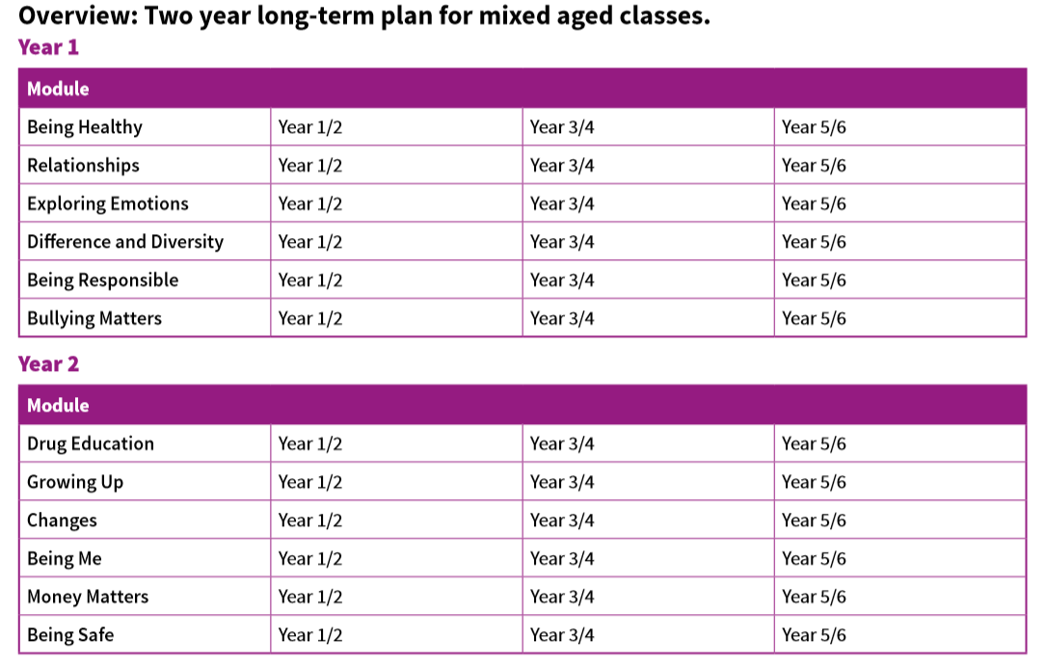

Assessment

Assessment is central to effective, quality teaching and learning in PSHE. The teaching, learning and assessing of PSHE recognises the following principles:

- To be successful independent learners, children and young people need regular opportunities to reflect on and identify what they have learnt, what needs to be learnt next and what they need to do to continue their learning.

- To enable this to happen, assessment has to be an integral part of the teaching and learning process and needs to focus on clear learning outcomes related to the curriculum and not on behavioural outcomes only. This is important as we are assessing skills, attitudes, knowledge and understanding not behaviour.

Effective assessment in PSHE requires that the teacher
- find out what pupils already know and understand before embarking on a theme.
- Share learning objectives and outcomes with pupils which will help them to understand the standard of knowledge, how to be successful and skills to aim for or achieve
- Provide formative feedback that helps pupils to identify how to improve
- Teach pupils self-assessment techniques and strategies so that they are able to assess their developing knowledge, understanding, attitudes and skills.
- Differentiate activities
- Include time for reflection and action within the session
- If pupils aren't achieving, consider which different strategies we can put in place to support them more effectively.
Resources
The school has a full range of resources to support the teaching of this subject however, the principle vehicle is the PSHE Matters scheme of work and its associated teaching and assessment resources.

Staffing / Staff Development
All staff take part in professional development to ensure secure subject knowledge, awareness of health and safety procedures and up to date knowledge. Staff should be comfortable and competent in the area of activity being taught. Staff should indicate where they feel they need support so that appropriate support can be given either by the subject leader or through continued professional development. Any staff who attend a CPD course should provide feedback/ disseminate the information as appropriate.

Cross Curricular
PSHE contributes to many subjects within the primary curriculum such as computing, Science, English and maths. R.E. also often has links to our topic work. These links are made explicit to children and are used as a means to develop cross-curricular links.

Monitoring and Evaluation of the Subject
Monitoring of standards of children's work and the quality of teaching is the responsibility of the subject coordinator supported by the Headteacher and the Senior Leadership Team.
Standards will be monitored by:
- lesson drop ins
- lesson observations
- work and planning monitoring
- pupil voice
- Staff questionnaires
- Audit of subjects
Assessment and Recording
Assessment will take place at short-term and medium-term levels by the class teacher. These assessments will be used to inform teaching in a continuous cycle of planning, teaching and assessment.
Short-term assessment will be an informal part of every lesson. The teacher will share the objectives for the lesson with the children and make sure they are clear what is being expected of them to successfully achieve the objective. This is a necessary part of Assessment for Learning and will involve the teacher checking the children’s understanding at the end of the session to inform future planning and lessons.

Monitoring the Effectiveness of the Policy
The practical application of this policy will be reviewed annually or when the need arises by the coordinator, the Headteacher and the nominated governors.

