BRITISH VALUES STATEMENT

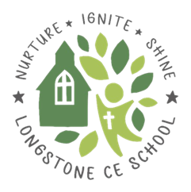

Reviewed/Adopted: April 25
Next Review Date: April 27
Review Frequency: Two years
Reviewed By: CAS

Reviewed/Adopted: January 2023
Next Review Date: January 2025
Review Frequency: Two years
Reviewed By: CAS

Reviewed/Adopted: January 2023
Next Review Date: January 2025
Review Frequency: Two years
Reviewed By: CAS

British Values Statement for Longstone C of E Primary School

The DfE have reinforced the need ‘to create and enforce a clear and rigorous expectation on all schools to promote the fundamental British values of democracy, the rule of law, individual liberty and mutual respect and tolerance of those with different faiths and beliefs.’

The Department for Education defines British Values as follows:

- Respect for democracy and support or participation in the democratic process
- Respect for the basis on which the law is made and applies in England
- Support for equality of opportunity for all
- Support and respect for the liberties of all within the law
- Respect for and tolerance of different faiths and religious and other beliefs

At Longstone Primary School, these values are engrained within our vision and school charter (see below). They are taught through our broad, balanced and enriched curriculum. British Values is an ongoing theme within our whole school assemblies. The citizenship award is geared around the qualities that we believe make a good Longstone, and British, citizen. Frequent opportunities are provided so that our pupils can apply the key learning behaviours that; promote their spiritual, moral, social and cultural development; and support the school's vision to create valued members of our local and wider communities who have a positive impact on the world.

Longstone Primary Schools work in partnership with governors, parents, the community, the Diocese and the local authority to achieve these aims.

At Longstone Primary School we will actively challenge pupils, staff or parents expressing opinions contrary to fundamental British Values, including 'extremist' views.



I am important and so are you,
We listen to one another and learn whilst we do.
We show respect for all who we meet,
In grace, in triumph or defeat.

We work together as a team to ignite our passions
and create our dreams.

We are proud of our school and all that we do.

Watch us change, watch us grow, facing challenges
as we go.

Nurture, Ignite, Shine at Longstone Primary School.
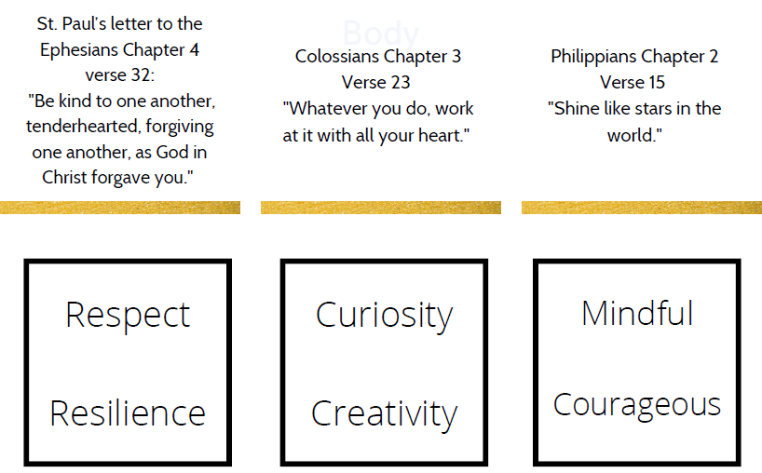
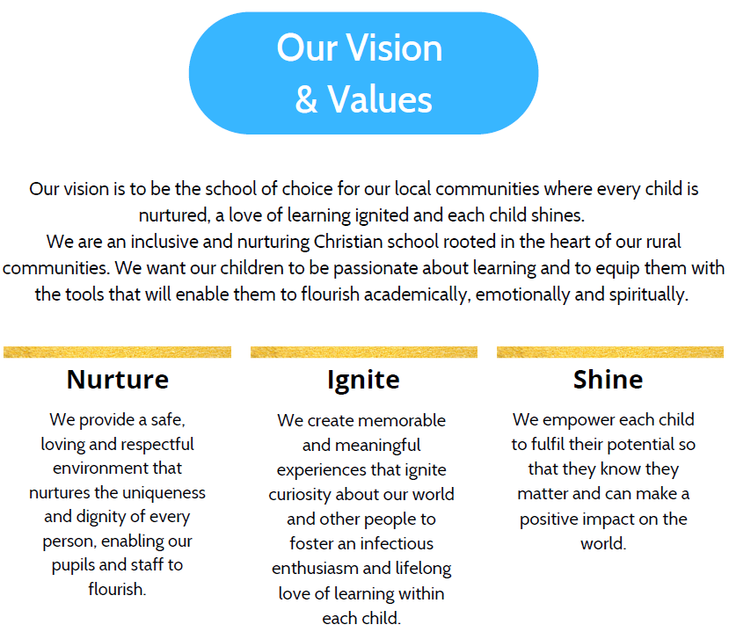

At Longstone Primary School, we actively promote British values in the following ways:

Democracy

The Pupil Parliament plays an active part of the decision-making processes at Longstone Primary School. Members are voted for by their class and they regularly feature as a part of the whole school decision making process, taking and sharing information from their weekly meetings and then presenting back their findings in order that opinions and ideas can be sought e.g. the new school vision.

The children in each class vote to decide the Citizen of the Term awards. Pupil explanations are recorded on each certificate.

Parents complete a range of questionnaires as part of our ongoing consultation process. These comments are used to improve the school.

Pupil voice is used as a tool for school improvement. Pupil questionnaires have been used by subject leaders to prioritise actions and to evaluate the success/impact of change.

The principle of democracy is explored through the curriculum as well as during assemblies and special days or themes (e.g. SMILERS or diversity).

The Rule of Law

A consistently applied Behaviour Policy is to be shared with the children (due to be updated in light of the new vision).

The current rules are integral to our learning, values and ethos. School rules and expectations are clear, fair and regularly promoted. Children are rewarded for making positive choices.

Pupils' modelling behaviour consistent with the school's high expectations are recognised and used as role models to others e.g. Reception buddies.

Pupils are always helped to distinguish right from wrong, in the classroom, on the playground and during school visits.

Through collective worship and the school's curriculum, children develop an understanding of law appropriate to their age.

Access to high quality text gives pupils a safe way of exploring the 'breaking' of laws and an opportunity to discuss consequences when this occurs.

Pupils are taught explicitly that laws keep us safe and our curriculum enables pupils the opportunity to recognise when they do and do not feel safe e.g. Safer Internet Day.

Visits from other external agencies such as the fire service, health professionals and 'People who help us' reinforces their understanding of the responsibilities held by various professions.

The Behaviour and Anti-Bullying policies set out a zero-tolerance baseline for any form of aggression, abuse or violence, which extends to pupils, staff and parents and carers.

Individual Liberty

Protective behaviours are taught across the school and every child is aware that they have the right to feel safe. They are also taught that there is nothing too awful that they cannot talk to an adult about. Within school, pupils are actively encouraged, and given the freedom to make choices, knowing that they are in a safe and supportive environment.

Pupils are encouraged to take responsibility for their behaviour and our pastoral support reinforces the importance of making the right choices.

Pupils are encouraged to know, understand and exercise their rights and personal freedoms and are advised how to exercise these safely, for example through our e-safety teaching and PSHE lessons.

Children are valued for their differences and these are celebrated.

Pupils are supported to develop their self-knowledge, self-esteem and self-confidence.

There is a wide variety of opportunities to enable children to try new things, develop new skills and practise existing ones. Care is taken to provide equal opportunities for all genders such as boys and girls and mixed sports teams.

Time and care are taken to know each child as an individual and regular PSHE, well-being, RSHE and citizenship sessions give children a chance to share their feelings and options in a safe way.

Opportunities for children to take on more responsibility within the school is encouraged e.g. sport leaders, buddies etc.

Vulnerable pupils are protected and stereotypes challenged. A strong anti-bullying culture is embedded in the school and any form of bullying is challenged and addressed. The school governing body has taken an active role in this and the results of a whole-school pupil survey were widely published. The school also operates a robust system of logging incidents and responding to them.

Mutual Respect and tolerance of those of different faiths and beliefs

Respect is one of the core values of our school. The pupils know and understand that it is expected and that respect is shown to everyone.

Through our curriculum, pupils are helped to acquire an understanding of, and respect for, their own and other cultures, personal choices and ways of life. We offer a culturally rich and diverse curriculum in which all major religions are studied and respected and global dimension work embedded in many of our creative curriculum topics, such as India. These curriculum topics offer children the chance to reflect on our core values and British values.

The school follows the agreed Derbyshire Religious Education (RE) syllabus which ensures that the children learn about all the religions of the world.

Collective worship contributes to the knowledge of all religions of the world.

Staff and pupils are encouraged to challenge extreme, prejudicial or discriminatory behaviour.

Links and visits are promoted with local faith communities and places of worship.

Through the PSHE, RSHE and RE curriculums pupils are encouraged to discuss and respect differences between people, such as differences of faith, ethnicity, disability, gender or sexuality and differences of family situations.

Our citizenship and diversity themes ensure an understanding and tolerance of the richness of difference in British society.

Anti-Bullying week is held annually and various well-being events are held across the year. During these sessions, children are taught to value differences in others and themselves and to respect others.

Many children at Longstone Primary School participate in local sports events and competitions both within our cluster and at a community level. These ensure children experience competitive events and have an opportunity to apply their sportsmanship skills with other schools.

In Conclusion

Part of our vision at Longstone Primary School is to prepare the children of the future to become valued members of society. Promoting British Values enables children to develop a sense of community and begin to understand their responsibilities and role within it.

